Outcomes Data

Biology Major & Composite Teaching Major

Objective 1
Graduates will be able to demonstrate analytical and experimental scientific skills.
Since Spring 2020, we download outcomes data from Canvas at the end of each academic year. We filter the data to analyze data for biology majors only (raw data: https://usu.box.com/s/vzwwyxy55avtjq974vayr1jx1xm9ey2x). We look at mastery (2/3 score) in each course as well as improvement across the curriculum. To look at patterns not due to attrition, for the subobjectives that have enough data, we track individual student progress from early to late undergraduate career.

Key to the objectives, subobjectives ,and the courses in the following graphs:
1a. Graduates will be able to practice the process of science.
1a.1: Introduction - Context
1a.2: Introduction - Accuracy and relevance
1a.3: Methods
1a.4: Results
1a.5: Discussion - Conclusion
1a.6: Discussion - Limitations
1a.7: Discussion - Implications
1a.8: References
1b. Graduates will be able to use quantitative reasoning, modeling, and simulation to solve problems in biology.
1b.3 Statistical analyses
Early scores: Required introductory lab sequence for biology majors (BIOL 1615 & 1625)
Late scores: Required intermediate lab courses for which 1625 is a prerequisite (BIOL 3020, 3055, 3060, 3065, 3070, 3085) and BIOL 4060 (mostly senior biology majors for which 1625 is a prerequisite)
Points: Points are average scores across assessments and courses for individual biology majors. The more students with the same score, the darker the point.
Red dashes: Mastery score
Black diagonal lines: Points above the diagonal line show progress over time

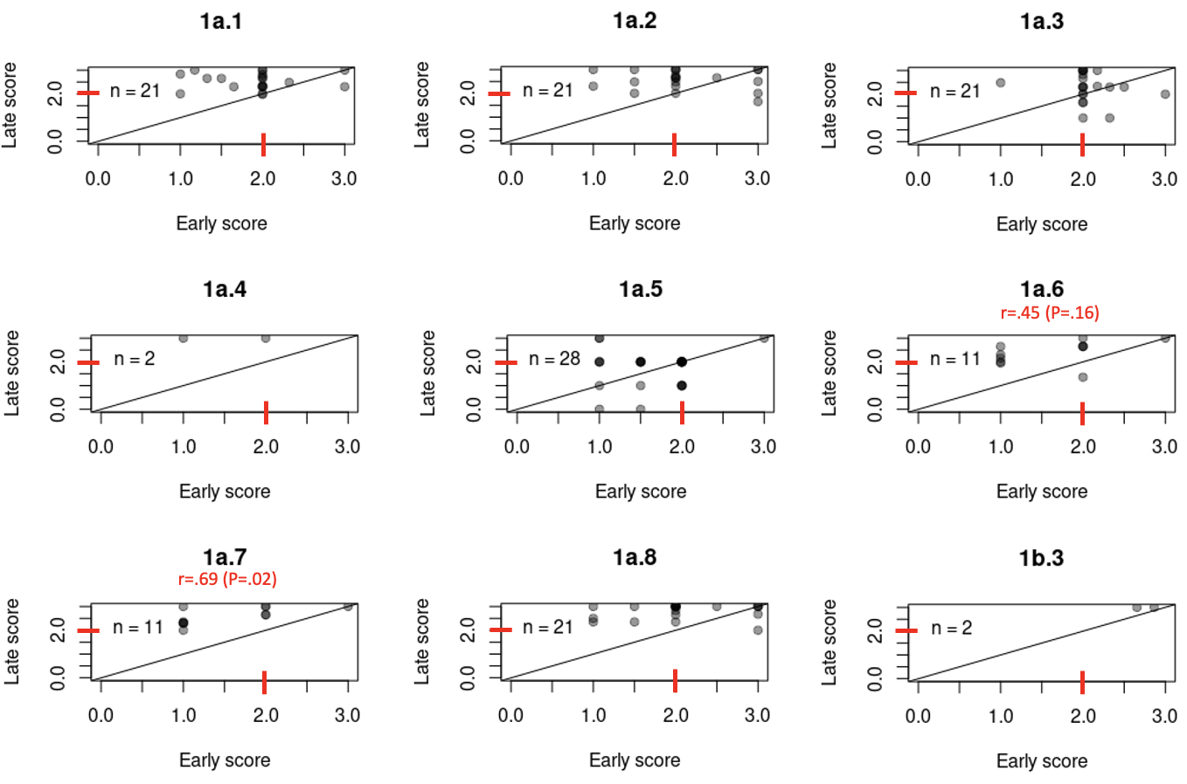

Trends based on these results from Spring 2020-Spring 2023: Most students are improving from early to late courses, as most points are above the diagonal line. This includes a greater proportion of students mastering objectives in late than early courses, as more late scores are above 2. Importantly, most students are mastering these learning objectives by the time they take intermediate to upper-level courses, as most scores are at or above 2 in the late courses. We do not have evidence that early and late scores are correlated for most objectives; students who did well writing about project limitations (1a.6) and implications (1a.7) early also did so later. Perhaps the lack of evidence for correlations suggests we are helping all students improve, regardless of pre- or early college experience, or we could get this pattern from variability in grading across courses. Instructors should discuss consistency in grading on 1a.3 and 1a.5 in particular, as there were more points below the diagonal.

Objective 2
(leave as is)

Objective 3
Graduates will acquire the practices of professional scientists.
Since Spring 2020, we download outcomes data from Canvas at the end of each academic year. We filter the data to analyze data for biology majors only (raw data: https://usu.box.com/s/vzwwyxy55avtjq974vayr1jx1xm9ey2x). We look at mastery (2/3 score) in each course as well as improvement across the curriculum. To look at patterns not due to attrition, for the subobjectives that have enough data, we track individual student progress from early to late undergraduate career.

Key to the objectives, subobjectives ,and the courses in the following graphs:
3b. Communicate biological concepts and interpretations to scientists in other disciplines and the general public.
3b.1: Writing quality
3b.2: Clear choice of language (oral)
3b.3: Technical use of media, tactical use of media, use of mental images to support (oral) explanation.
Early scores: Required introductory lab sequence for biology majors (BIOL 1615 & 1625)
Late scores: Required intermediate lab courses in which 1625 is a prerequisite (BIOL 3020, 3055, 3060, 3065, 3070, 3085) and BIOL 4060 (mostly senior biology majors for which 1625 is a prerequisite)
Points: Points are average scores across assessments and courses for individual biology majors. The more students with the same score, the darker the point.
Red dashes: Mastery score
Black diagonal lines: Points above the diagonal line show progress over time

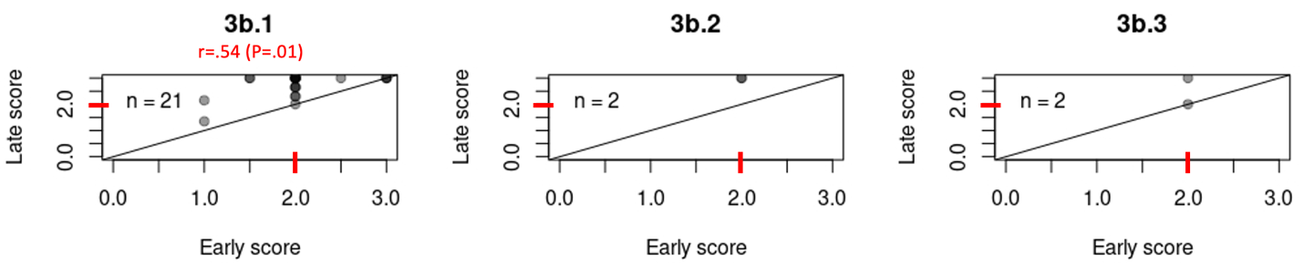

Trends based on these results from Spring 2020-Spring 2023: Most students are improving from early to late courses, as most points are above the diagonal line. This includes a greater proportion of students mastering objectives in late than early courses, as more late scores are above 2. Importantly, most students are mastering these learning objectives by the time they take intermediate to upper-level courses, as most scores are at or above 2 in the late courses. Students who did well with writing quality (3b.1) early also did so later. This might suggest it could be harder to help students improve poor writing quality in a short amount of time, a skill that is honed since elementary school. Incentivizing the use of the Science Writing Center might help students further improve writing quality skills.

Last updated: August 2023

